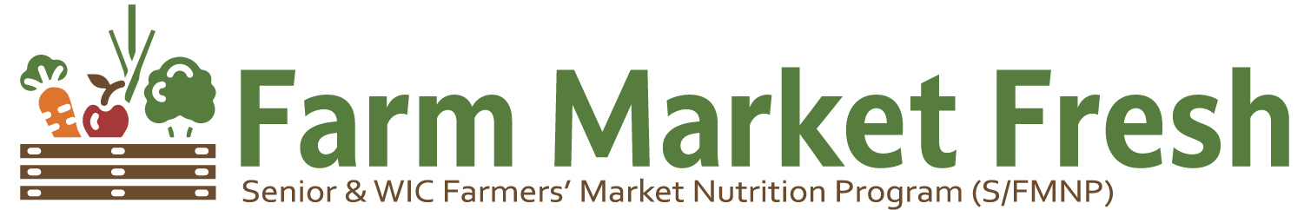
2024 Senior Application
Please Print | Today’s Date: ____/____/____

Applicant #1 | Applicant #2 - Same Household Unit (Optional)
Name:____________________________ | Name:___________________________
Last, First MI | Last, First MI
Birthdate:_______/_______/_______ | Birthdate:_______/_______/_______
(Month) (Day) (Year) (Month) (Day) (Year)
Address of Residence:_________________________________________________________
Street
________________________________________________________________________________________
City State Zip County
☐Mailing Address is same as Residence
Mailing Address:______________________________________________________________
Street
________________________________________________________________________________________
City State Zip County
Email (optional):_______________________________________
Home Phone:_________________________ Cell Phone:_________________________
Applicant #1 Demographics |  | Applicant #2 Demographics
Ethnicity: Mark one, regardless of Race | Race: Mark one or more | Ethnicity: Mark one, regardless of Race | Race: Mark one or more
☐Hispanic or Latino | ☐ American Indian or Alaskan Native | ☐ Hispanic or Latino | ☐ American Indian or Alaskan Native
☐Not Hispanic or Latino | ☐ Asian | ☐ Not Hispanic or Latino | ☐ Asian
☐Prefer not to answer | ☐ Black or African American | ☐Prefer not to answer | ☐ Black or African American
 | ☐ Native Hawaiian or Pacific Islander |  | ☐ Native Hawaiian or Pacific Islander
 | ☐White |  | ☐White
 | ☐Prefer not to answer |  | ☐Prefer not to answer

Office Use Only:
Voucher Numbers Issued:_____________________________ Staff Initials:________ Date:______________
Self-Declaration for Income Eligibility
Number of People in Household: ____________
Total Monthly Household Income: ____________

2024 Senior Application
Certification - By my signature below I certify that

I understand that it is unlawful to receive farmer’s market checks from more than one locality or to enroll in this program more than one time each Market Season. I have been advised of my rights and obligations under the SFMNP. I certify that the information I have provided for my eligibility determination is correct, to the best of my knowledge. This certification form is being submitted in connection with receipt of Federal assistance. Program officials may verify information on this form. I understand that intentionally making a false or misleading statement or intentionally misrepresenting, concealing, or withholding facts may result in my repaying the Virginia Department for the Aging, in cash the value of the food benefits improperly issued to me and may subject me to civil or criminal prosecution under State and Federal law.

I understand that I may appeal any decision made by the local agency regarding my eligibility for the SFMNP. I understand the Program’s household income eligibility guidelines or have had them explained to me. I hereby acknowledge with my signature that my household family income is within the published income eligibility guidelines for participation in SFMNP.

Signature of Applicant #1:_________________________________ Date:____________

Signature of Applicant #2:_________________________________ Date:____________

Return Completed Applications To This Address or Email:

District Three Governmental Cooperative
4453 Lee Highway, Marion, VA 24354
jreedy@district-three.org

2024 Senior Application

USDA Non-Discrimination Statement

DO NOT mail completed applications to the address below. The address below is to file a program complaint of discrimination.
In accordance with federal civil rights law and U.S. Department of Agriculture (USDA) civil rights regulations and policies, this institution is prohibited from discriminating on the basis of race, color, national origin, sex (including gender identity and sexual orientation), disability, age, or reprisal or retaliation for prior civil rights activity.
Program information may be made available in languages other than English. Persons with disabilities who require alternative means of communication to obtain program information (e.g., Braille, large print, audiotape, American Sign Language), should contact the responsible state or local agency that administers the program or USDA’s TARGET Center at (202) 720-2600 (voice and TTY) or contact USDA through the Federal Relay Service at (800) 877-8339.
To file a program discrimination complaint, a Complainant should complete a Form AD-3027, USDA Program Discrimination Complaint Form which can be obtained online at: https://www.usda.gov/sites/default/files/‌documents/ad-3027.pdf, from any USDA office, by calling (866) 632-9992, or by writing a letter addressed to USDA. The letter must contain the complainant’s name, address, telephone number, and a written description of the alleged discriminatory action in sufficient detail to inform the Assistant Secretary for Civil Rights (ASCR) about the nature and date of an alleged civil rights violation. The completed AD-3027 form or letter must be submitted to USDA by:
- mail:
U.S. Department of Agriculture
Office of the Assistant Secretary for Civil Rights
1400 Independence Avenue, SW
Washington, D.C. 20250-9410; or
- fax:
(833) 256-1665 or (202) 690-7442; or
- email:
Program.Intake@usda.gov

This institution is an equal opportunity provider.
02/15/2023

